CRIMINAL MANAGEMENT SYSTEM
ABSTRACT
Criminal management System is a system used to report crimes. This project is mainly useful for police Departments. This system will help to manage all the activities in a police Department using computers. Currently all the works are done manually, by computerizing all the activities inside a police Department can be managed easily and effectively. The police Departments in the country are, today, virtually unconnected islands. Thanks to telephones and wireless, and especially thanks to mobile telephones, there is voice connectivity between the police Department and senior police officers, but that is about all. There is no system of data storage, data sharing and accessing data. There is no system under which one police Department can talk to another directly.
There is no record of crimes or criminals that can be accessed by a Department House Officer, except the manual records relating to that police Department. The goals of the system are to facilitate collection, storage, retrieval, analysis, transfer and sharing of data and information at the police Department and between the police Department and the State Headquarters and the Central Police Organizations.

SYSTEM SPECIFICATION
HARDWARE SPECFICATION:
- Processor : P 4 700 GHz.
- RAM : 4 GB RAM
- Hard Disk Drive : 180 GB

SOFTWARE SPECIFICATION:

  - Operating System : Windows 7/8/10
  - Front End : JAVA
  - Back End : ORACLE

EXISTING SYSTEM:
This system is very hard to find criminals which may cause some issues. It can’t be searching the criminal list if we want to search the particular criminal very difficult to tracking. Criminals details are stored as document wise so we can’t search the criminals.
DRAWBACKS:
The existing system has the following drawbacks.
- There is not possible to find one particular criminal detail.
- Lot of paper to be wasted
- It takes too much time to register the criminal details

PROPOSED SYSTEM:
In this criminal finder system easily find the person has any case or not. Using an author id based we can find the criminal details which could be easy to find the criminal details. Any time anywhere we can see about the criminal detail, we no need to take the file anywhere.
FEATURES:
- Easy to find criminal
- Fully systematic process
- No one will be escaped

SYSTEM DEVELOPMENT
DESCRIPTION OF MODULES
- Criminal Registration
Criminals data has register in this module which can maintain the criminals report. We can’t identify the criminal’s details before registration
- Police Registration
This module contains collect all the information about the police, this module collects username and password as well, based on this we can able to login to this application.
- Allocate case
In this will be allocate the criminal case which could be easily identify the case wise criminal reports.
- Search Criminals
Search criminal’s module will help to identify the criminal by its author number. This is a main module in this project. Which may be avoid unwanted issues.
- Criminal History
This module will be showing an history of criminal’s record. Which is used to find the past criminal case.

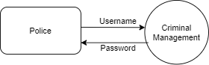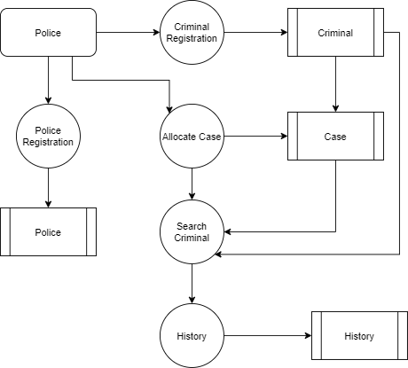

TABLE NAME : POLICE
FIELD | DATA TYPE | SIZE | CONSTRAINT
Police id | Int | 10 | Primary key
Police name | Varchar | 20 | Not null
Department | Varchar | 20 | Not null
Degree | Varchar | 20 | Not null
Username | Varchar | 20 | Not null
password | Varchar | 20 | Not null
TABLE NAME: CRIMINAL
FIELD | DATA TYPE | SIZE | CONSTRAINT
First name | Int | 10 | Primary key
Lastname | Varchar | 30 | Not null
Aadhar number | Varchar | 30 | Not null
Mobile | Int | 10 | Not null
Age | Int | 5 | Not null
Gender | Varchar | 10 | Not null
address | Varchar | 30 | Not null

TABLE NAME: CASE
FIELD | DATA TYPE | SIZE | CONSTRAINT
Case id | Int | 10 | Primary key
Case name | Varchar | 20 | Not null
Case number | Int | 20 | Not null

TABLE NAME: HISTORY
FIELD | DATA TYPE | SIZE | CONSTRAINT
History id | Int | 10 | Primary key
Aadhar number | int | 20 | Not null
First name | Varchar | 30 | Not null
Last name | Varchar | 20 | Not null
Mobile | Int | 10 | Not null
Age | Int | 10 | Not null
Gender | Varchar | 5 | Not null
Address | Varchar | 30 | Not null
Case name | Varchar | 20 | Not null
description | Varchar | 30 | Not null

